**Individual Visualization Makeover Assignment**

You may choose either of the following options for this assignment (you are NOT required to do both, but are welcome to do so):

**Option 1**

Your job is to use Tableau to implement a better version of this visualization:

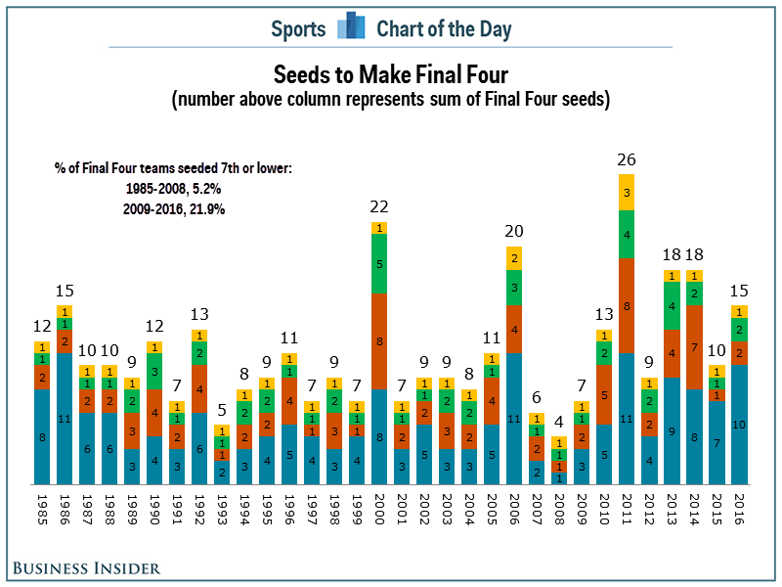

The data used for this submission is called “NCAA Mens March Madness Historical Results” and is available through Sakai.

To revise this image for this assignment, choose an interesting “data story” you think the data can tell. You can choose any data story that you find compelling, and are allowed to be creative in how you revise the visualization. However, you must describe the purpose of your visualization and your “data story” in an accompanying document, and will be expected to explain your rationale for the changes you made.

**Option 2**

Your job is to participate in this week’s “Makeover Monday” run by Eva Murray and Andy Kriebel:

<http://www.makeovermonday.co.uk/data/>

For public exposure, by **Tuesday, Feb. 4**, submit a picture of your “makeover” and a link to the interactive version to:

<https://www.makeovermonday.co.uk/submit/>

To get feedback from Andy & Eva, post your visualization on Twitter using the using the #MakeoverMonday (tag @VizWizBI & @TriMyData) and #MMVizReview hashtag in your tweet. Then join their [live webinar](http://makeovermonday.co.uk/webinars/)on Feb. 4 or Feb. 5 at 4 PM GMT (which should be 11 AM EST). Register for it at <https://www.makeovermonday.co.uk/webinars/>. **NOTE:** Webinars are usually held on Wednesdays, which would be Feb. 5. For some reason, though, their website suggests they have scheduled the webinar on Feb. 4 of next week, which would be a Tuesday. I have a feeling this was simply a scheduling mistake on their part, but I will do my best to gain clarity about which day the webinar will be held by Monday, Feb. 3. Either way, their webinars are recorded and posted, so as long as you submit your visualization in time, you should be able to watch the video to get feedback at your convenience.

**For Both Options, please submit to Sakai by 11 PM on Tuesday, Feb. 4:**

1. A packaged Tableau workbook with your final visualization. Make sure your name is included in the title of your submissions and that your packaged workbook is fully functional for somebody who will be opening the workbook on another computer. You will not receive credit for this assignment if your name is not part of the file name or if we cannot open your workbook because you created your extract incorrectly. Instructions for how to create a packaged workbook can be found here:

http://onlinehelp.tableau.com/current/pro/desktop/en-us/save_savework_packagedworkbooks.html

1. A separate word document with your answers to the following questions:
   1. What dashboard/worksheet/story should your reviewers look at in your Tableau workbook to see your final visualization?
   2. What do you think the take-home message(s) of the original visualization was/were supposed to be?
   3. What did the original visualization do well?
   4. What aspects of the original visualization needed to be improved, and why?
   5. What “data story” did *you* want to tell using this data set, and what was the purpose of *your* visualization? Note: there is no correct answer to this, because you are welcome to focus on whatever data story you want. However, we need to know what you intended in order to give you feedback about how well your chosen story was conveyed.
   6. What changes did you make to the visualization compared to the original?
   7. How did your changes improve the original visualization?

You must complete this assignment independently, without help from other class members. **You are allowed to use internet resources to help you figure out how to implement things in Tableau, but you are NOT allowed to use internet resources for any other purpose.** **If we determine that you used somebody else’s revision of the same visualization to influence your solution, you will receive no credit for this assignment.**

Be prepared to discuss your submission in class.

You will be evaluated on the thoughtfulness and completeness of your answers, your application of the visualization practices we have discussed in class, the overall effectiveness of the visualization, and your creativity.